

**Information Security COMP-421**

Section-B

Assignment 2

Mahnoor Khalid 241555407

**Successful Command Run:**

**Listing**

**msfvenom -l payloads #Payloads**

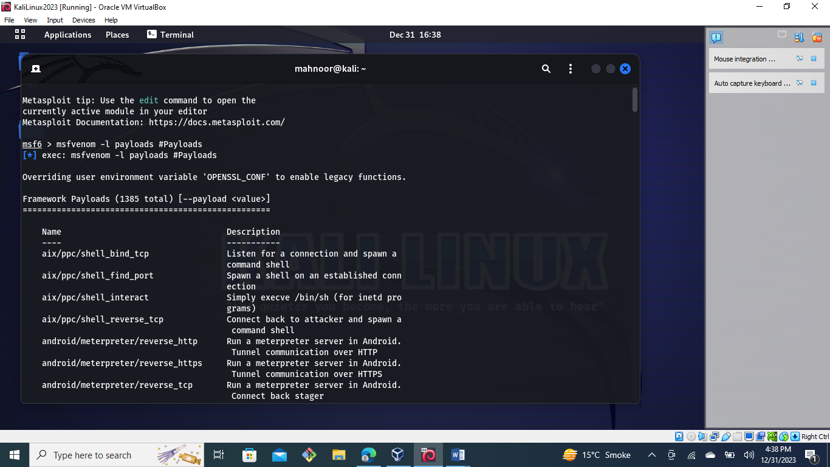

**msfvenom -l encoders #Encoders:**

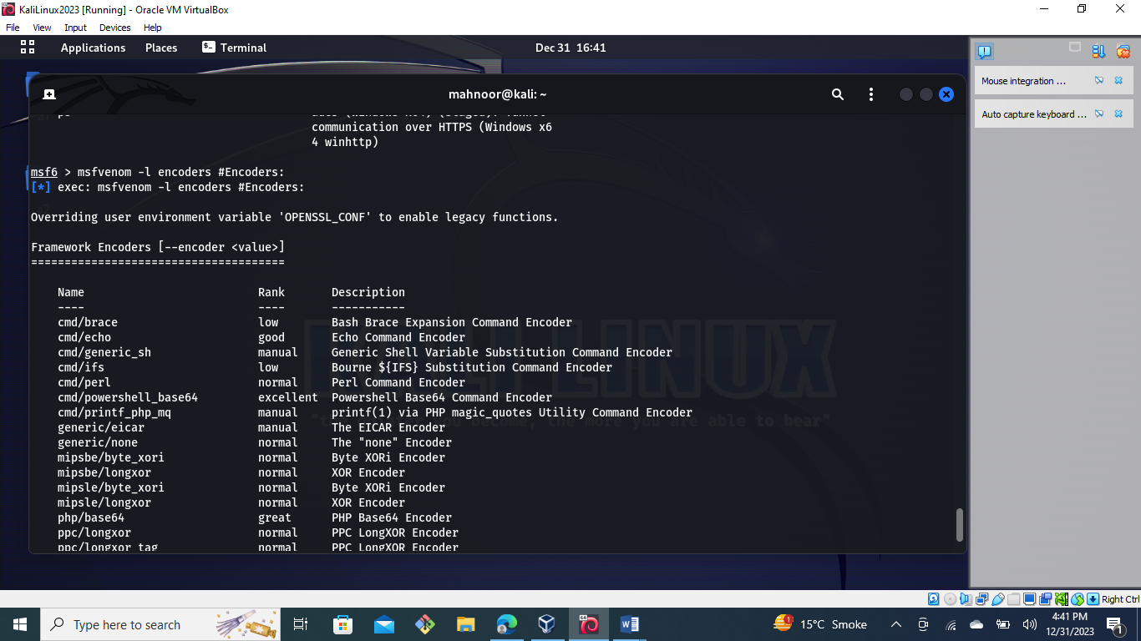

**Windows**

**Reverse Shell:**

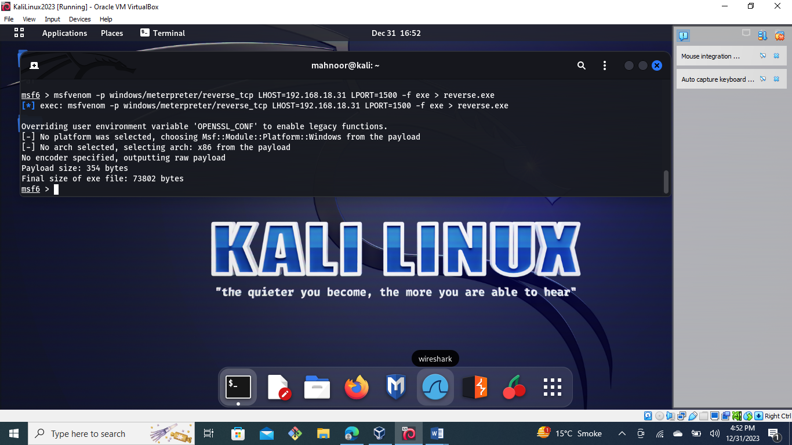

**Bind Shell:**

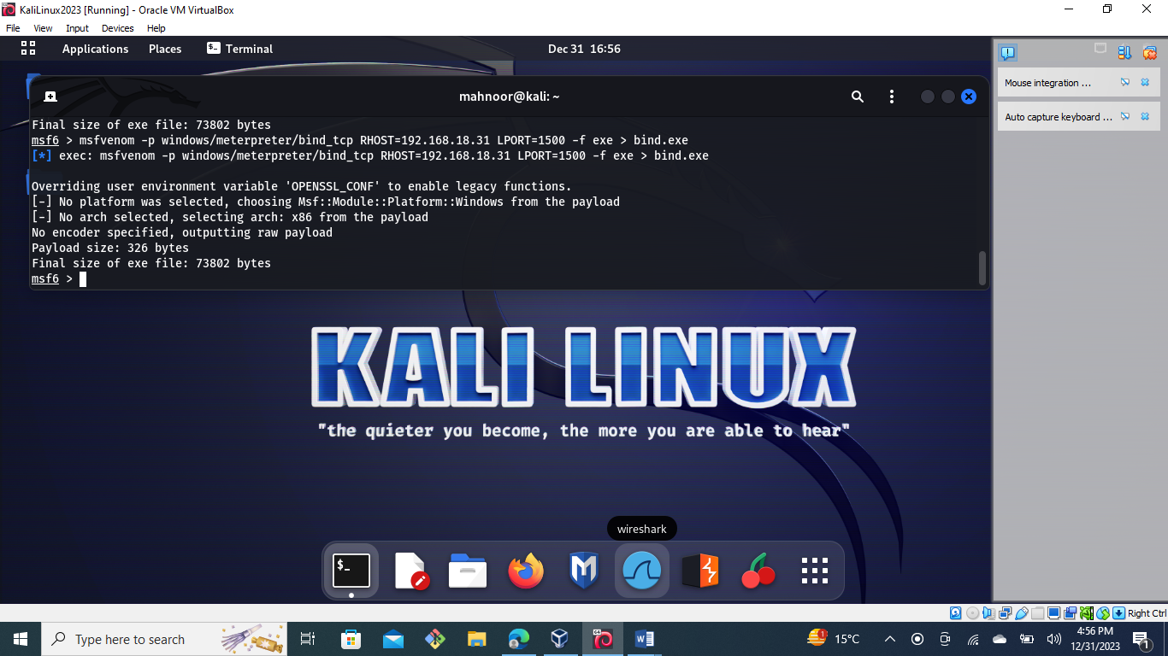

**Create User:**

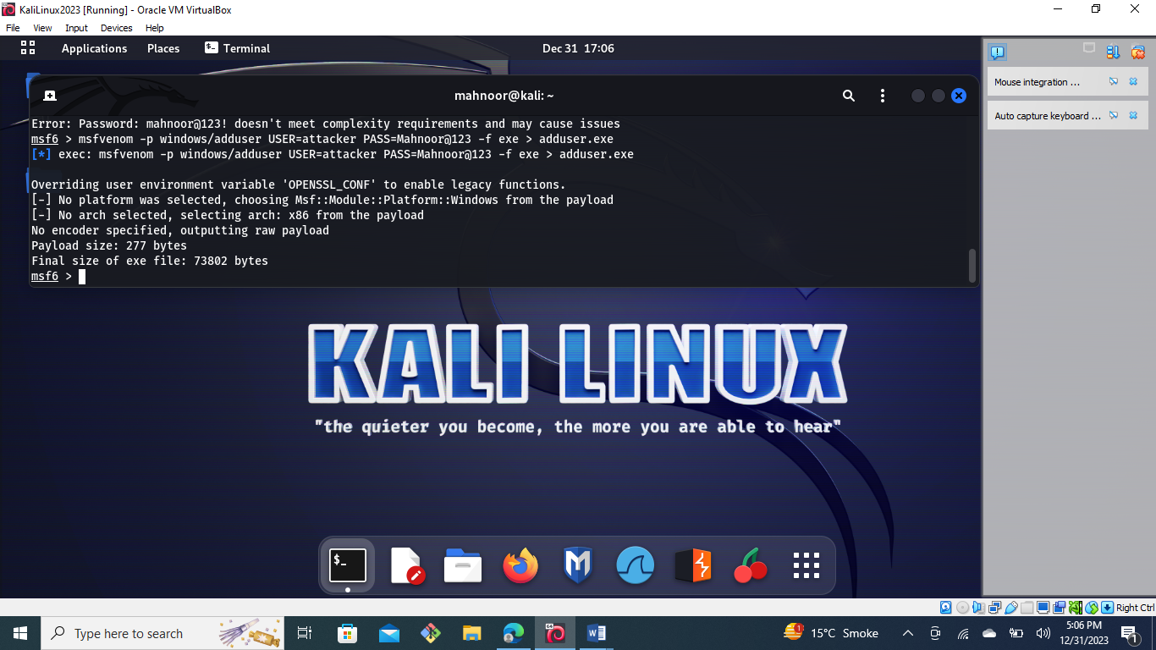

**CMD Shell:**

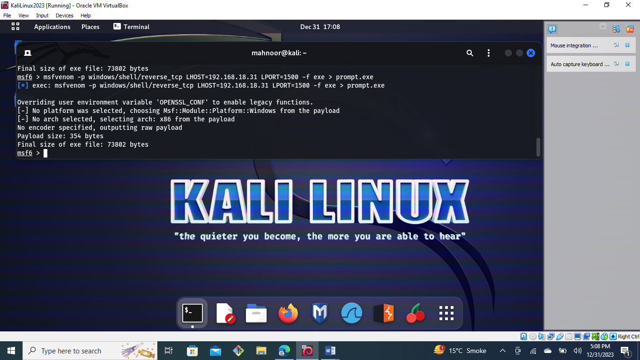

**Execute Command:**

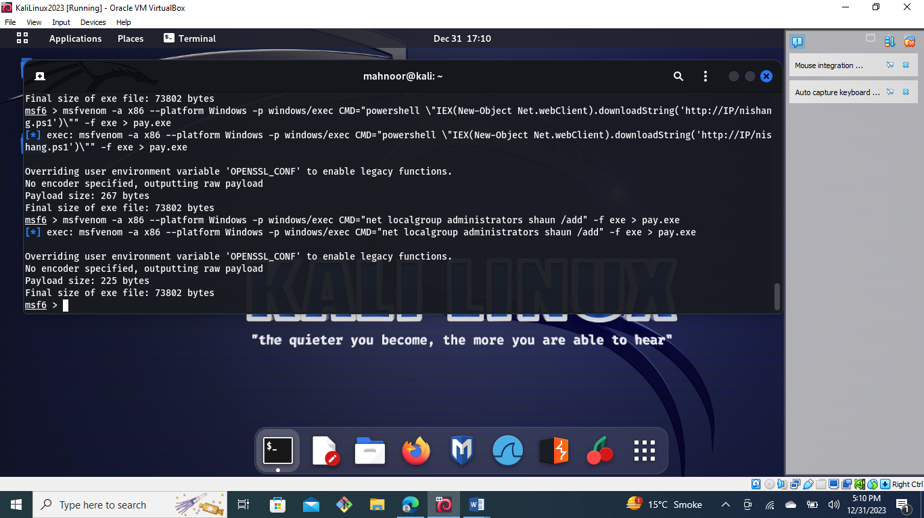

**Encoder:**

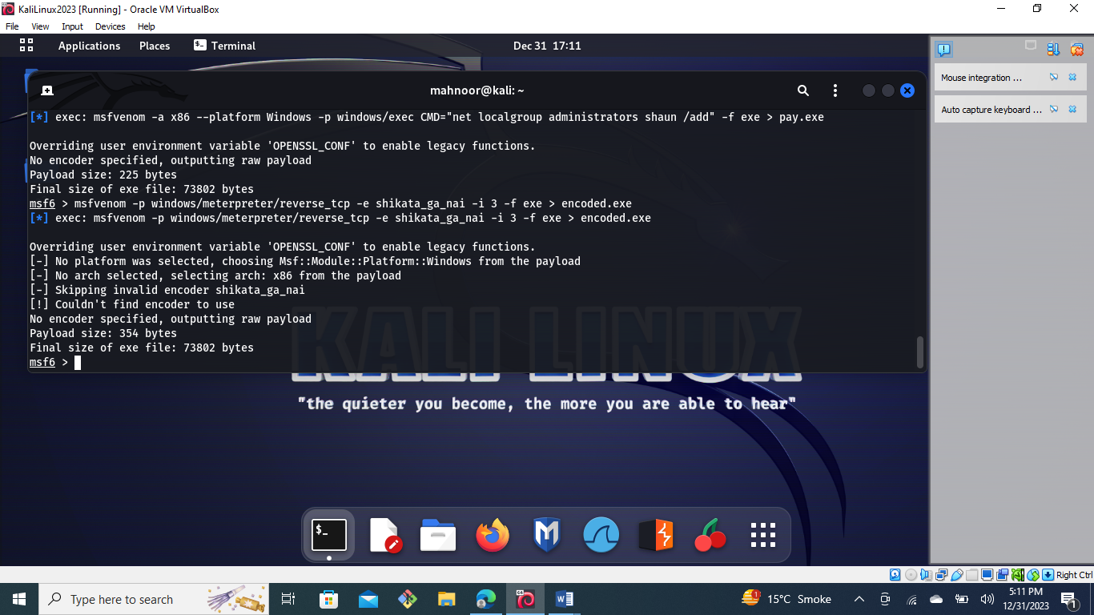

**Embedded inside executable:**

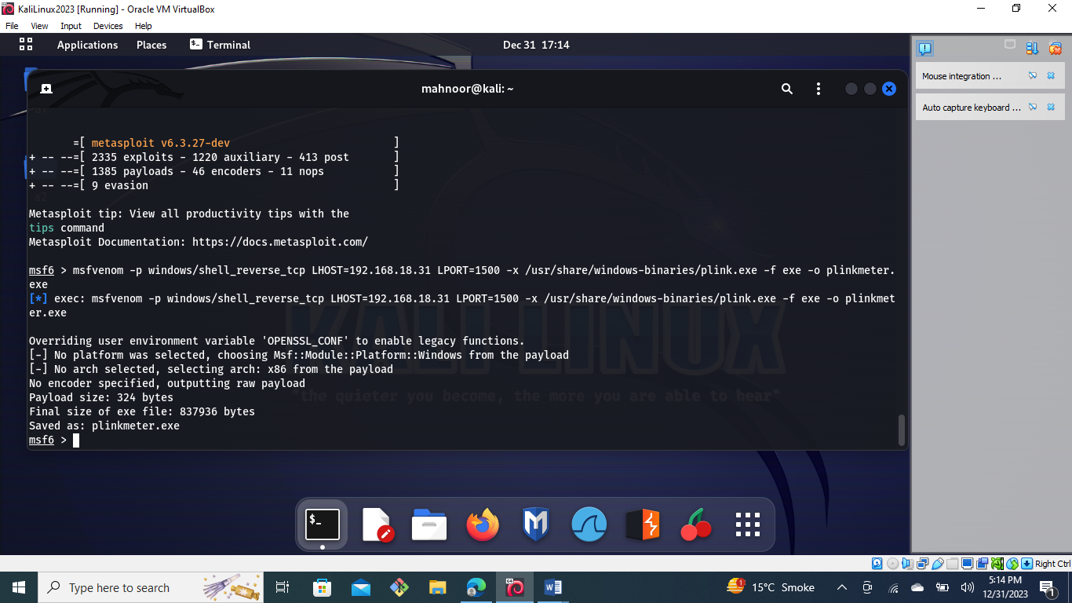

## Linux Payloads

### Reverse Shell:

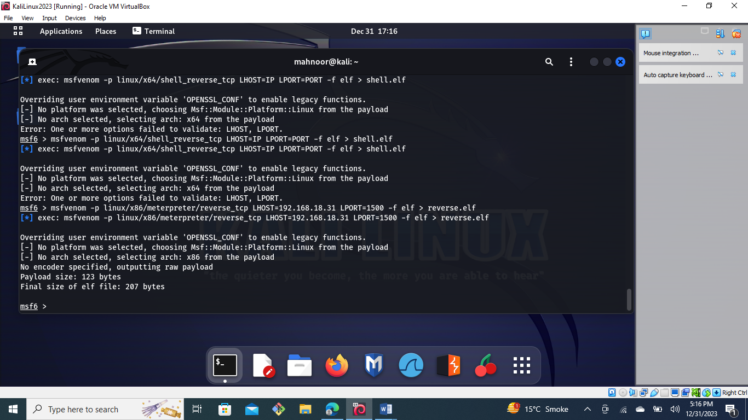

### Bind Shell:

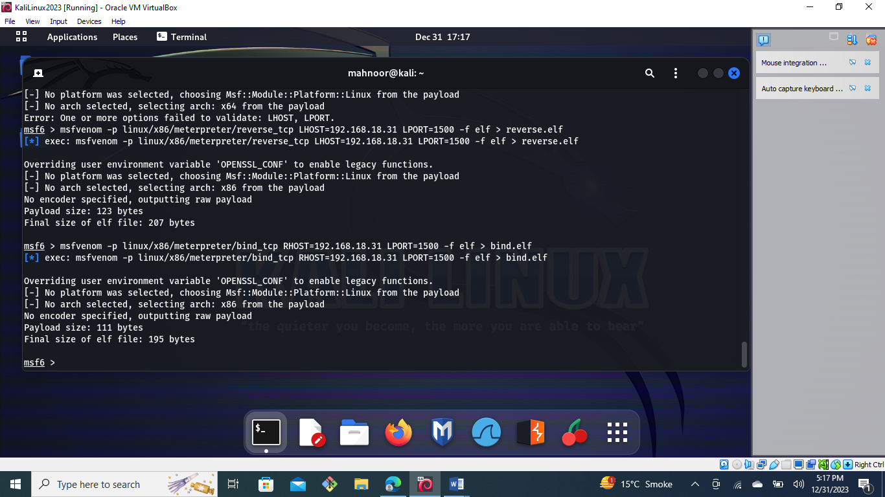

**SunOS (Solaris):**

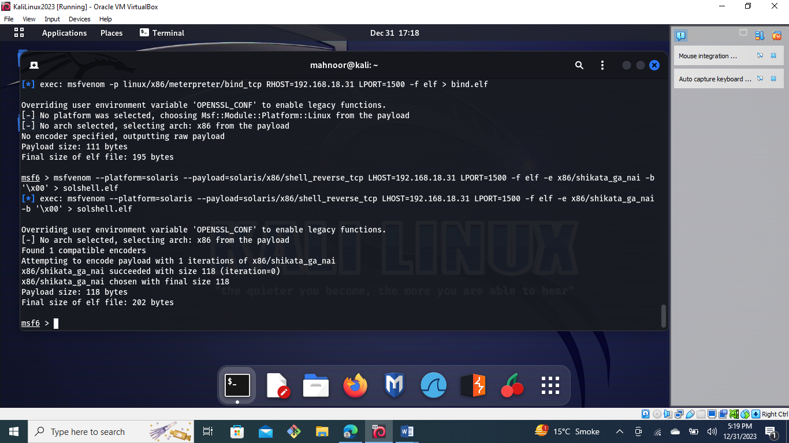

## **MAC Payloads**

### **Reverse Shell:**

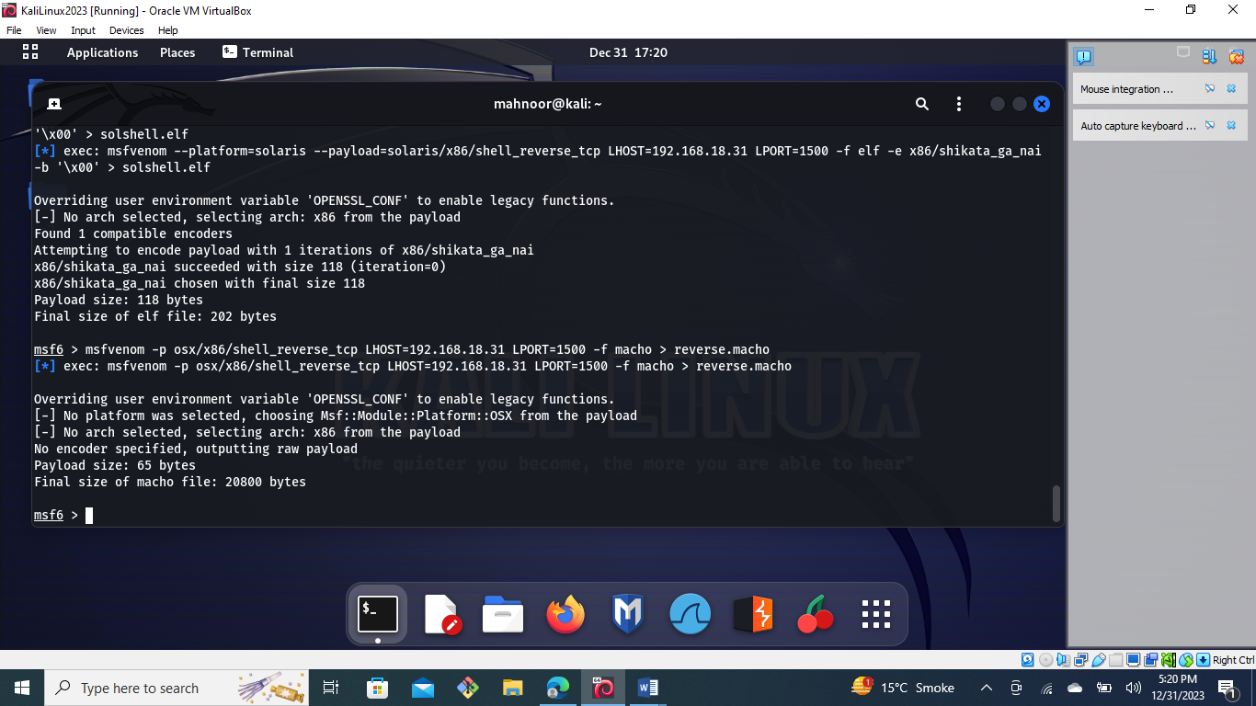

**Bind Shell:**

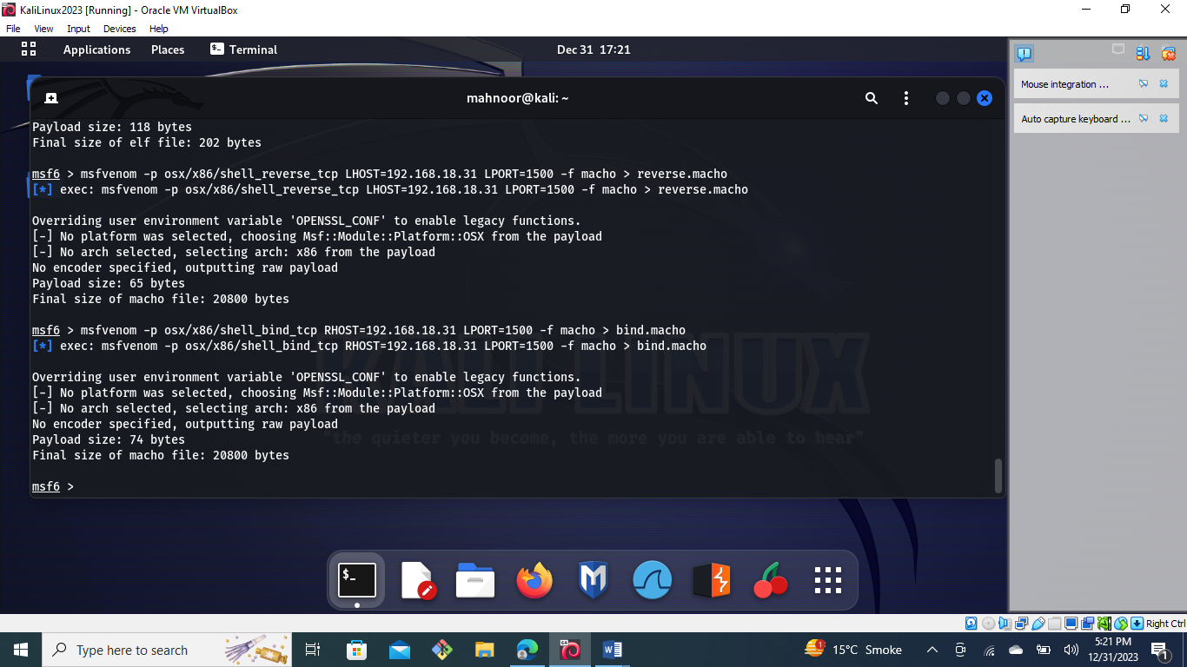

## **Web Based Payloads**

### **PHP**

### **Reverse Shell:**

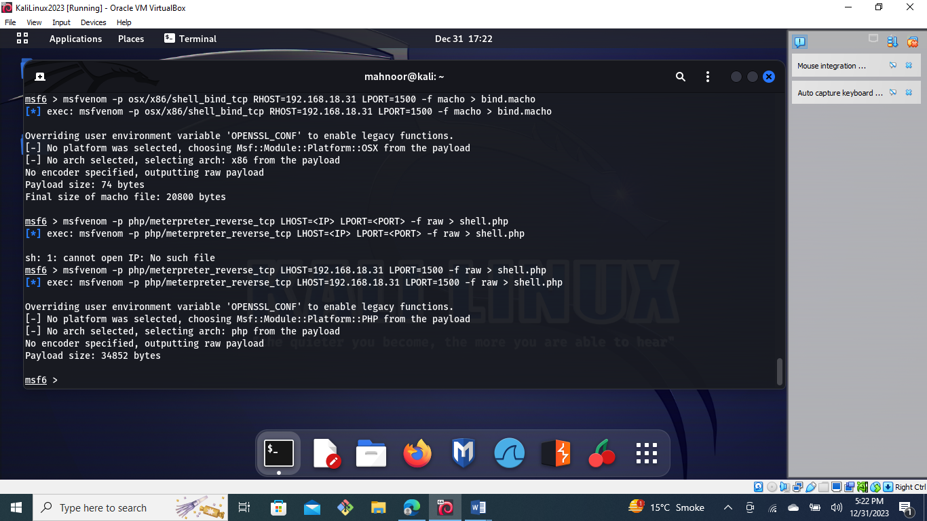

### ASP/x

### **Reverse Shell:**

### 

### JSP

### **Reverse Shell:**

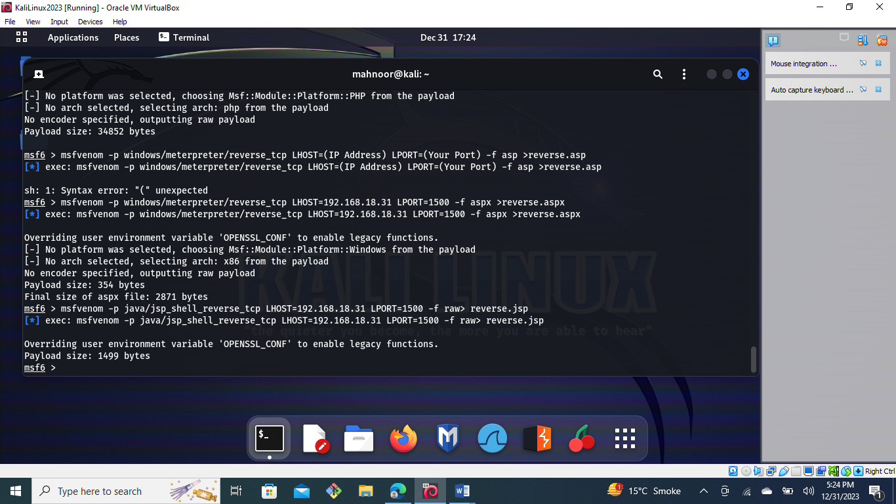

**WAR**

### **Reverse Shell:**

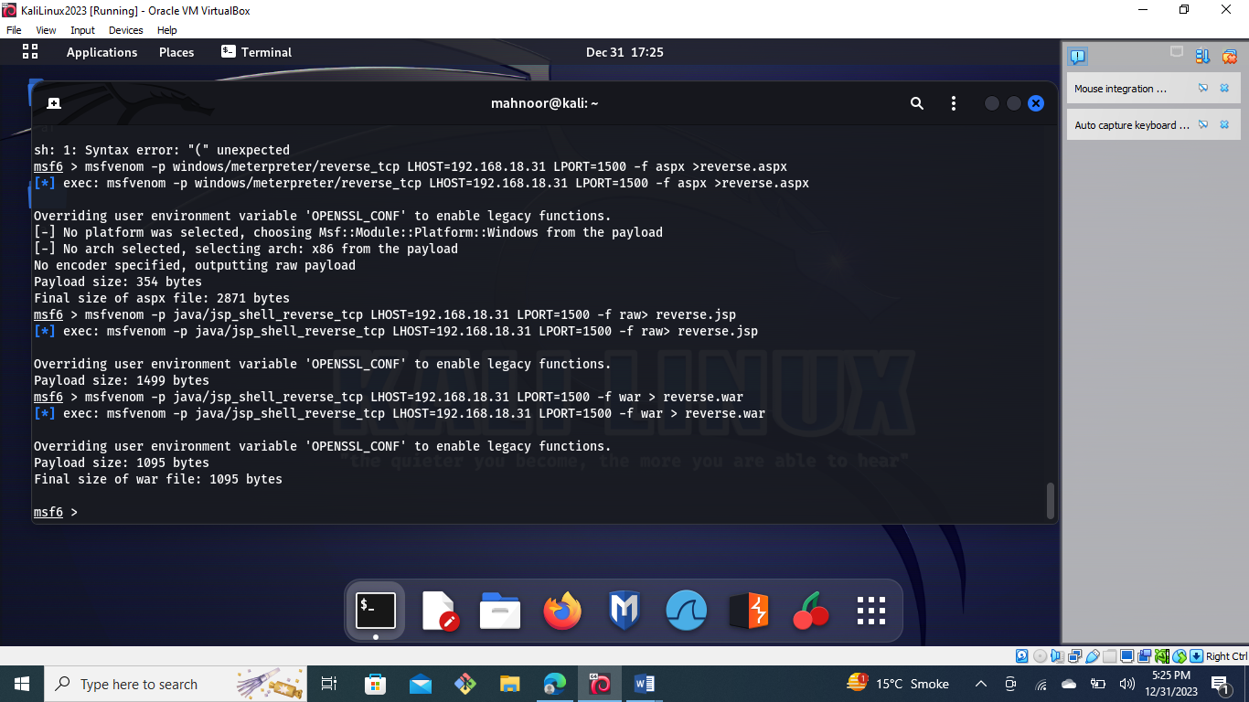

**NodeJS:**

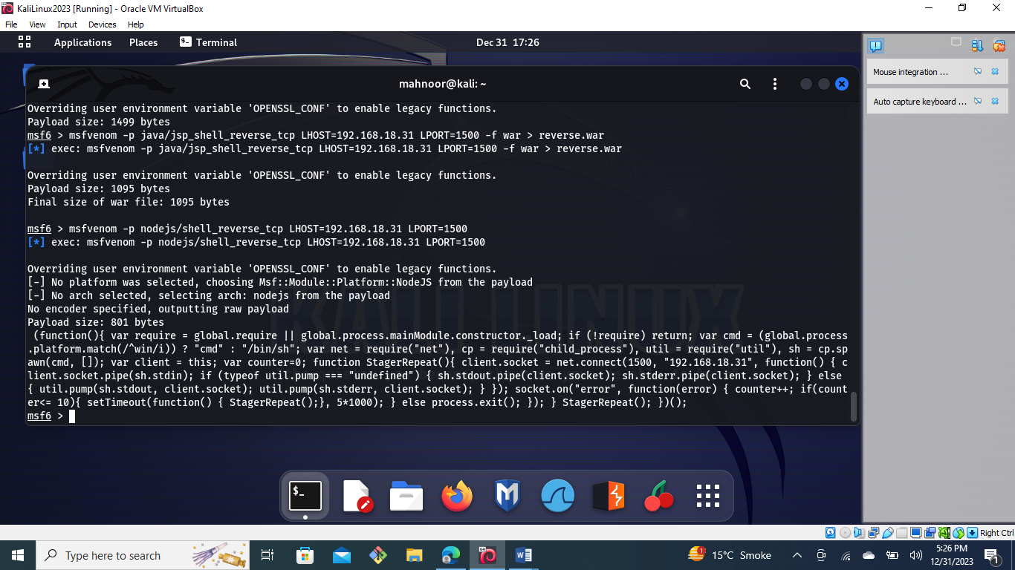

## **Script Language payloads**

### **Perl:**

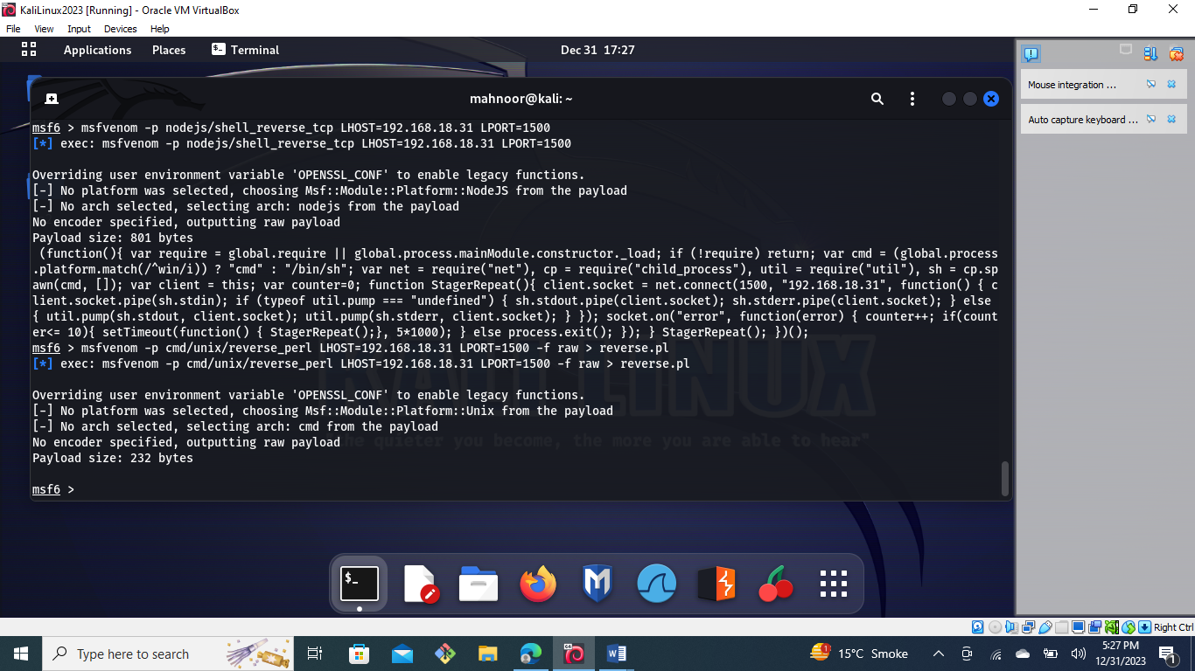

### Python:

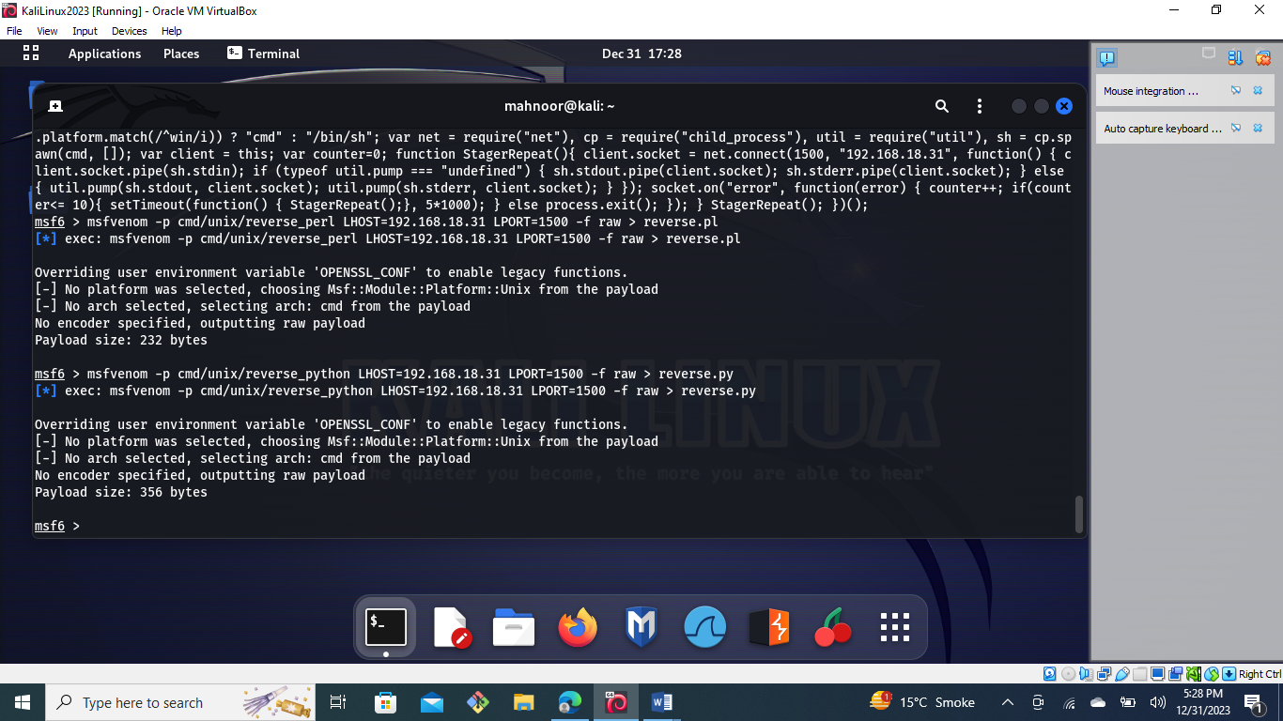

### Bash:

